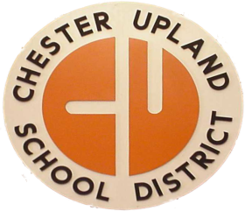

Consent to Use Picture and/or Quote
Chester Upland School District
232 W. 9th Street – Administration Building
Chester PA 19013

I hereby give permission to the Chester Upland School District, to interview, audiotape, photograph, videotape, film, or capture by any other electronic means the image of my child. In signing this form, I hereby release any and all actions and claims which I, my child, my family members, our heirs, executors or administrators may have against the Chester-Upland School District and its employees, representatives, agents, successors and assigns, the Education Empowerment Board and any and each of its members, arising for any reason whatsoever from the use, publication, distribution, or republication of the words or images gathered.

I warrant that I am at least eighteen (18) years of age and acknowledge that I have thoroughly read and understand this Waiver and Release Form.

Please Print
Student Name: ______________________________School/Grade:_____________________

Signature
Parent/Guardian:_____________________________ Date:______________________

As the parent of a student under the age of eighteen (18), I hereby give permission to the foregoing.

Signature
Parent/Guardian Name: _______________________________ Date: _______________

